Packet Tracer - Skills Integration Challenge
Topology
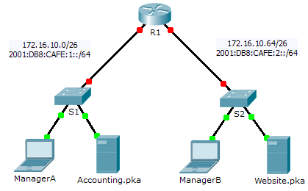
Addressing Table
Device | Interface | IPv4 Address | Subnet Mask | Default Gateway
Device | Interface | IPv6 Address/Prefix |  | Default Gateway
R1 | G0/0 | 172.16.10.1 | 255.255.255.192 | N/A
R1 | G0/0 | 2001:DB8:CAFE:1::1/64 |  | N/A
R1 | G0/1 | 172.16.10.65 | 255.255.255.192 | N/A
R1 | G0/1 | 2001:DB8:CAFE:2::1/64 |  | N/A
R1 | Link-local | FE80::1 |  | N/A
S1 | VLAN1 | 172.16.10.62 | 255.255.255.192 | 172.16.10.1
S2 | VLAN1 | 172.16.10.126 | 255.255.255.192 | 172.16.10.65
ManagerA | NIC | 172.16.10.3 | 255.255.255.192 | 172.16.10.1
ManagerA | NIC | 2001:DB8:CAFE:1::3/64 |  | FE80::1
Accounting.pka | NIC | 172.16.10.2 | 255.255.255.192 | 172.16.10.1
Accounting.pka | NIC | 2001:DB8:CAFE:1::2/64 |  | FE80::1
ManagerB | NIC | 172.16.10.67 | 255.255.255.192 | 172.16.10.65
ManagerB | NIC | 2001:DB8:CAFE:2::3/64 |  | FE80::1
Website.pka | NIC | 172.16.10.66 | 255.255.255.192 | 172.16.10.65
Website.pka | NIC | 2001:DB8:CAFE:2::2/64 |  | FE80::1
Scenario
Your company has won a contract to set up a small network for a restaurant owner. There are two restaurants near each other, and they all share one connection. The equipment and cabling is installed and the network administrator has designed the implementation plan. You job is to implement the rest of the addressing scheme according to the abbreviated Addressing Table and verify connectivity.
Requirements
- Complete the Addressing Table documentation.
- Configure R1 with IPv4 and IPv6 addressing.
- Configure S1 with IPv4 addressing. S2 is already configured.
- Configure ManagerA with IPv4 and IPv6 addressing. The rest of the clients are already configured.
- Verify connectivity. All clients should be able to ping each other and access the websites on Accounting.pka and Website.pka.
Suggested Scoring Rubric
Packet Tracer scores 80 points. Completing the Addressing Table is worth 20 points.

